1.Train ‘A’ running at speed of 54 km/hr crosses a platform of length same as that of the train in 36 sec. If train B, which is 230 meters long crosses the same platform in 25 sec, then find speed of train B (in km/hr)?

1. 54 km/hr

2. 72 km/hr

3. 84 km/hr

4. 90 km/hr

5. 108 km/hr

Solution:

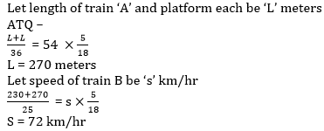

2.Speed of a boat in still water is 12 kmph and speed of stream is ‘x’ kmph. If in traveling 270 km upstream boat takes 66 ⅔% more time than traveling 270 km downstream, then find the value of ‘x’.

1. 2 kmph

2. 4 kmph

3. 1 kmph

4. 3 kmph

5. 6 kmph

Solution:

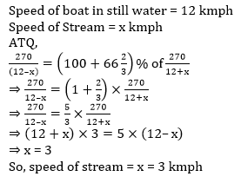

3.A boat covers a distance of 50 kms in 2 hours in downstream. If speed of stream is 5 kmph, then find time taken by boat to cover 45 km in upstream and 50 km in downstream.

1. 5 hours

2. 4 hours

3. 4.5 hours

4. 5.5 hours

5. None of these

Solution:

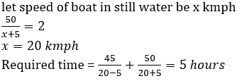

4.A boat covers ‘x+20’ km downstream or ‘x-5’ km upstream in 5 hours. If speed of boat in still water is 300% more than speed of stream. find x.

1. 42.5

2. 40

3. 45

4. 37.5

5. 35

Solution:

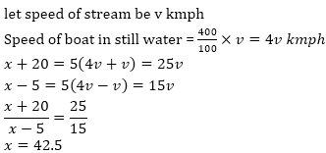

5.A train crosses a man, who is running in the same direction of train at the speed of 2m/sec. in 10 seconds. The same train crosses a tunnel in 54 seconds. If speed of train is 72 km/h then what is the length of tunnel?

1. 850 m

2. 800 m

3. 900 m

4. 750 m

5. 650 m

Solution:

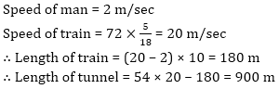

6.A boat can travel with the speed of 17 kmph in upstream. If the speed of river is 3 kmph, then find the speed of boat in downstream in the same river.

1. 23 kmph

2. 20 kmph

3. 25 kmph

4. 19 kmph

5. 21 kmph

Solution:

Speed of boat in upstream = 17 kmph

Speed of river water = 3 kmph

So speed of boat in still water = 17 + 3 = 20 kmph

So speed of boat in downstream = 20 + 3 = 23 kmph

7.Sum of length of two train is 540 m and ratio of speed of two trains A and B is 1 : 2. If train A covers 90 m in 5 sec/ Then in what time they will cross each other when they travel in opposite direction.

1. 11 s

2. 8 s

3. 12 s

4. 10 s

5. 15 s

Solution: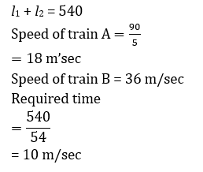

8.The distance between two trains is 350 km and they approach towards each other on parallel tracks. If speed of one train is 80% of speed of other train and they take 10 hours to meet each other then find the speed of slower train.

1. 

2. 

3. 

4. 

5. 

Solution: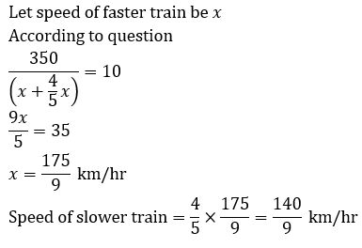

**9.**A boat while travelling upstream covers a distance of 18 km at the speed of 3 km/h, whereas while travelling downstream it covers the same distance at a speed of 9 km/h. What is the speed of the boat in still water?

1. 3 km/h

2. 5 km/h

3. 7 km/h

4. Cannot be determined

5. None of these

Solution:

10. Two trains starting at the same time from two stations, 200 km apart and going in opposite directions, cross each other at a distance of 110 km from one of them. What is the ratio of the speed of faster train to slower train ?

1. 11 : 20

2. 9 : 20

3. 11 : 9

4. 19 : 20

5. 9 : 11

Solution: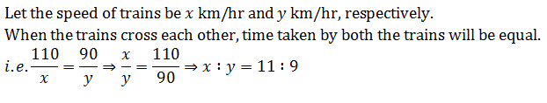

**11.**A boat takes 90 minutes less to travel 36 miles downstream than to travel the same distance upstream. If the speed of the boat in still water is 10 m/h, the speed of the stream is:

1. 4 m/h

2. 3 m/h

3. 2.5 m/h

4. 2 m/h

5. 3.5 m/h

Solution:

Suppose speed of the stream =K m/h

Speed of the boat in still water = 10 m/h

∴ Boat will travel with the stream (downstream) at (10 + K) m/h and boat will travel against the stream (upstream) at (10 – K) m/h.

Now, from the question,

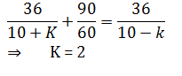

**12.**The distance between Shaurya’s house and Pratyusha’s house is 18 km. Shaurya’s speed is 3/4 th of that Pratuyusha. Shaurya takes one hour in going to Pratyusha’s house. What is the speed of Pratyusha ?

1. 18 kmph

2. 24kmph

3. 30kmph

4. 32kmph

5. None of these

Solution:

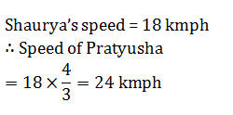

**13.**A boat covers 18 km downstream in 3 hours. If speed of current is of its downstream speed then in what time it will cover a distance of 100 km upstream.

1. 50 hour

2. 40 hour

3. 30 hour

4. 60 hour

5. 25 hour

Solution: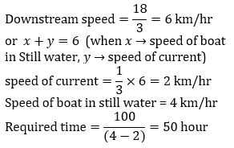

14.The time take by a boat in upstream is double than the time taken by it in downstream, but distance covered by it in upstream is only 75% of distance covered by it in downstream. Find the ratio of speed of boat in still water to speed of current.

1. 5 : 11

2. 11 : 7

3. 7 : 11

4. 11 : 3

5. 11: 5

Solution:

Let still water speed of boat is x km/hr and speed of current y km/hr

ATQ—

Let d be the distance covered by boat in downstream.

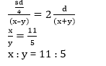

15.Train P can cross a pole in 32 seconds and it can cross a 1200 meters long platform in 72 seconds. If speed and length of train Q is 72 km/hr. and 1280 meters respectively, then find the time taken by train P to cross train Q, while both running in same direction,

1. 224 seconds

2. 176 seconds

3. 216 seconds

4. 196 seconds

5. 210 seconds

Solution:Let length and speed of train P be ‘l’ meters and ‘v’ m/sec respectively.

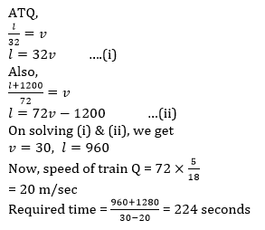

16.A man travels from Point P to Q with 90 km/hr and from Q to R with 60 km/hr. Total distance between P to R is 200 km. If his average speed is 75 km/hr then find the distance between P and Q?

1. 80 km

2. 120 km

3. 100 km

4. 150 km

5. None of the given options

Solution: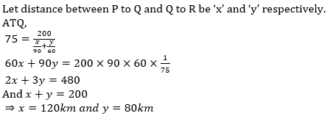

17.Train A which is 320m long can cross a pole in 16 seconds. If it halts 5 times each time for exactly 18 minutes, how many hours will it take to cover a distance of 576 kms? (in hours)

1. 

2. 

3. 

4. 

5. 

Solution:

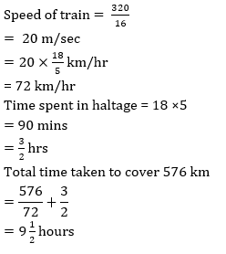

18.Sum of length of two trains A and B is 660. Ratio of speed of A and B is 5 : 8. Ratio between time to cross and electric pole by A and B is 4 : 3. Find the difference in the length of two trains.

1. 50

2. 60

3. 80

4. 75

5. 90

Solution: